**"TO ILLUSTRATE THE VALUES OF SIN AND COSINE FUNCTIONS FOR DIFFERENT ANGLES WHICH ARE MULTIPLES OF $π/2$**  AND $π$"

**A PROJECT WORK SUBMITTED FOR THE PARTIAL FULFILLMENT OF THE REQUIREMENT FOR THE GRADE 11 SCIENCE IN MATHS**

**By**

**Name:**

**Grade:**

**Roll No:**



**National Academy of Science and Technology(NAST)**

**National Education Board(NEB)**

**Dhangadhi, Kailali, Nepal**

**Date:**

**CERTIFICATE OF APPROVAL**

The project work entitled "TO ILLUSTRATE THE VALUES OF SIN AND COSINE FUNCTIONS FOR DIFFERENT ANGLES WHICH ARE MULTIPLES OF $π/2$ AND $π$" by Mr. __________________________ under the supervision of Mr. _________________________Of______________________________________________________________________, Nepal, is hereby submitted for the partial fulfillment of requirement of Maths in Grade 11. This project work has not been submitted in any other school or institution previously for the award of Grade 11.

__________________________________________ __________________________________________

Supervisor: Head of the Department:

**Mr. Khem Raj Pandey Mr. Krishna Singh Bhandari**

Department of Maths Department of Science

National Academy of Science National Academy of Science

and Technology(NAST) and Technology(NAST)

**DECLARATION**

I, ­­­­­­­­­­­­___________________ hereby declare that the project work entitled, "TO ILLUSTRATE THE VALUES OF SIN AND COSINE FUNCTIONS FOR DIFFERENT ANGLES WHICH ARE MULTIPLES OF $π/2$ AND $π$" under the supervision of Mr. ________________________Of____________________________________________________________________________ , Nepal, presented herein is genuine work done originally by me and has not been published or submitted elsewhere for the requirement of any degree program. Any literature, data or works done by others and cited in this project work has been given due acknowledgement and listed in the reference section.

_______________________

Grade:

E-mail address:

Date:

**TABLE OF CONTENTS**

**Chapter 1: Introduction**

**Chapter 2: Motivation**

**Chapter 3: Materials Required**

**Chapter 4: Objective**

**Chapter 5: Method of Construction**

**Chapter 6: Observation**

**Chapter 7: Literature Review**

**Chapter 8: Conclusion**

**Chapter 9: Acknowledgement**

**Chapter 10: References**

1. **Introduction:-**

**Trigonometric functions**are also known as **Circular Functions** can be simply defined as the functions of an angle of a triangle. It means that the relationship between the angles and sides of a triangle are given by these trig functions. The basic trigonometric functions are sine, cosine, tangent, cotangent, secant and cosecant.

The angles of **sine, cosine, and tangent** are the primary classification of functions of trigonometry. And the three functions which are cotangent, secant and cosecant can be derived from the primary functions.

### Sin Function:

### [Sin function](https://byjus.com/maths/sine-function/) of an angle is the ratio of the length of the perpendicular to that of the length of the hypotenuse of a given triangle. The value of sin function will be:

* **Sin a = Perpendicular/Hypotenuse**

### Cosine Function:

### Cosine function of an angle is the ratio of the length of the base to that of the length of the hypotenuse of a given triangle. The value of [cosine function](https://byjus.com/maths/cosine-function/) will be:

* **Cos a = Base/Hypotenuse**
* The trigonometric ratio table for six functions like Sin, Cos, Tan, Cosec, Sec, Cot, are:

1. **Motivation:-**

Early study of triangles can be traced to the [2nd millennium BC](https://en.wikipedia.org/wiki/2nd_millennium_BC), in [Egyptian mathematics](https://en.wikipedia.org/wiki/Egyptian_mathematics) ([Rhind Mathematical Papyrus](https://en.wikipedia.org/wiki/Rhind_Mathematical_Papyrus" \o "Rhind Mathematical Papyrus)) and [Babylonian mathematics](https://en.wikipedia.org/wiki/Babylonian_mathematics). Trigonometry was also prevalent in [Kushite](https://en.wikipedia.org/wiki/Kingdom_of_Kush) mathematics. Systematic study of [trigonometric](https://en.wikipedia.org/wiki/Trigonometric) functions began in [Hellenistic mathematics](https://en.wikipedia.org/wiki/Hellenistic_mathematics), reaching [India](https://en.wikipedia.org/wiki/India) as part of [Hellenistic astronomy](https://en.wikipedia.org/wiki/Hellenistic_astronomy). In [Indian astronomy](https://en.wikipedia.org/wiki/Indian_astronomy), the study of trigonometric functions flourished in the [Gupta period](https://en.wikipedia.org/wiki/Gupta_period), especially due to [Aryabhata](https://en.wikipedia.org/wiki/Aryabhata) (sixth century CE), who discovered the [sine function](https://en.wikipedia.org/wiki/Sine_function). During the [Middle Ages](https://en.wikipedia.org/wiki/Middle_Ages), the study of trigonometry continued in [Islamic mathematics](https://en.wikipedia.org/wiki/Islamic_mathematics), by mathematicians such as [Al-Khwarizmi](https://en.wikipedia.org/wiki/Al-Khwarizmi) and [Abu al-Wafa](https://en.wikipedia.org/wiki/Abu_al-Wafa).

1. **Materials Required:-**

* Chart Paper
* Sketch Pens
* Ruler or Scale
* Eraser

1. **Objective:-**

This project may help the students in understanding the values of trigonometric functions sin and cosine at different points.

1. **Method of Construction:-**

* Draw a graph keeping the values along y axis and trigonometric ratios along x axis.
* Connect the graph according to the values of sin and cosine function at the respective points.

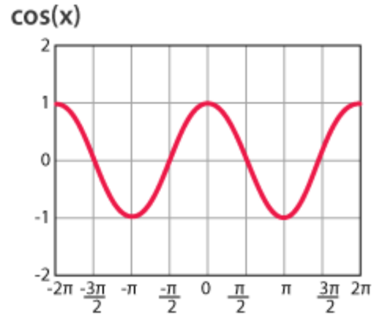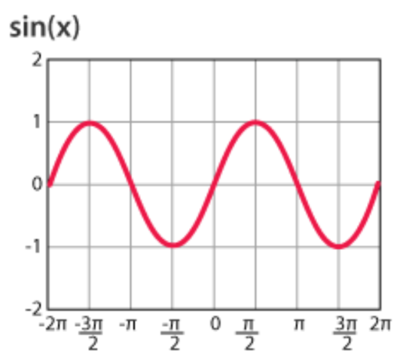

**Fig. Graph of sin and cosine functions on different angles**

1. **Observation:-**

From above graphs, the values of sin and cosine function can be observed as:

|  |  |  |  |  |  |
| --- | --- | --- | --- | --- | --- |
| **Trigonometric Ratios** | **0** | $$π/6$$ | $$π/4$$ | $$π/3$$ | $$π/2$$ |
| Sin θ | 0 | 1/2 | 1/√2 | √3/2 | 1 |
| Cos θ | 1 | √3/2 | 1/√2 | 1/2 | 0 |

Thus, in this way we can determine the values of trigonometric functions at different points using the help of graph.

1. **Literature Review:-**

Trigonometry is used to set directions such as the north south east west, it tells you what direction to take with the compass to get on a straight direction. It is used in navigation in order to pinpoint a location. It is also used to find the distance of the shore from a point in the sea. It is also used to see the horizon.

In marine engineering trigonometry is used to build and navigate marine vessels. To be more specific trigonometry is used to design the Marine ramp, which is a sloping surface to connect lower and higher level areas, it can be a slope or even a staircase depending on its application

1. **Conclusion:-**

Hence, the values of sin and cosine functions are illustrated at different points.

From this experiment, we came to know about the history, purpose and importance of trigonometry and its functions. These trigonometric functions have found their uses even in our daily lives. Even though it is difficult to understand trigonometry and its functions, it is a really interesting topic. This project also helped us in our course related matters.

1. **Acknowledgement:-**

I would like to express my special thanks of gratitude to my teacher Mr. _________________­­­­_____________ as well as our principal Mr. _________________________________ who gave us the golden opportunity to do this wonderful project on the topic “TO ILLUSTRATE THE VALUES OF SIN AND COSINE FUNCTIONS FOR DIFFERENT ANGLES WHICH ARE MULTIPLES OF $π/2$ AND $π$”, which also helped me in doing a lot of research and I came to know about so many new things I am really thankful to them.

Secondly, I would like to thank my parents and friends who helped me a lot in finalizing this project within the limited time frame.

1. **References:-**

* Pioneer Mathematics-I(Grade XI),Dreamland Publication by Mr. Gopal Neupane
* [www.wikipedia.com](http://www.wikipedia.com)
* [www.byjus.com](http://www.byjus.com)
* [www.mathnasium.com](http://www.mathnasium.com)